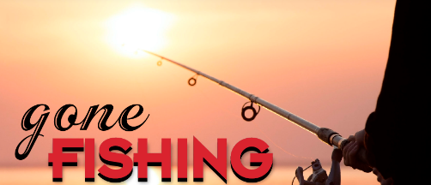

VFW Post 9857
Event: Fishing Trip, PERCH FISHING
Date: 4 October 2024
LOCATION: Port Clinton, OH

Hotel/Lodging: Best Western Port Clinton OH
Address: 1734 E Perry St, Port Clinton, OH 43452
Phone: (419) 734-2274

Fishing Boat:
Shore Nuf Charters, at Drawbridge Marina
247 W Lakeshore Dr, Port Clinton, OH 43452
Phone: (419) 734-9999
BOAT TIMES: 8 A.M. – 3 P.M.

Event Point of Contact: Charles Tate, 216-288-0456

Event Information:
4 October 2024:
The VFW Post 9857 Fishing Trip is scheduled for Friday October 4th and open to all VFW 9857 Members, VFW 9857 Auxillary Members and VFW 9857 Social Members with a current/updated dues status. The deadline to sign up for the fishing trip is September 15th. (See the above Point of Contact information.)

The VFW Post 9857 has chartered the fishing boat with Shore Nuf Charters, at Drawbridge Marina
(See above address and information). The Charter Boat is scheduled to deport at 8:00 AM with a return around 3:00 PM. Recommend all participants at the Shore Nuf Charters, Drawbridge Marina no later than 7:00 AM.

3 October 2024:
Lodging:
Those who seek to stay overnight on October 3rd, rooms have been reserved for the VFW Post 9857 guest at the Best Western Port Clinton OH (See above address and information). The VFW will not be officially registering individual(s) or pairing individuals to a room. Each person(s) must register themselves and their roommate at the lodging listed above, or at any lodging location you deem fit.
If you are interested in a roommate, see above Event Point of Contact information for a possible name for you to contact.

The Best Western Port in Clinton OH rooms all offer new high-definition TV with spectrum cable package and SHOWTIME® channels, single serve coffee maker, free high-speed internet access, refrigerator, microwave, in-room safe and more. With each stay, you'll also get a free hot breakfast with make-your-own Belgian waffles.

Travel/Transportation:
The VFW Post 9857 will not be coordinating transportation. Each person must seek their own travel arrangements. See above Event Point of Contact information for a possible name for you to contact.

On October 3rd at 6:00 pm, there will be a meet and greet in the front lobby of the Best Western Port Clinton OH. After the greeting, everyone is welcome to camaraderie at the local VFW 2480,214 Madison St, Port Clinton, OH 43452.

Fishing gear: Fishing rods and Tackle will not be provided by the Charter Boat company nor the VFW Post 9857. Each person must bring their own fishing rod(s) and tackle. If any assistance is required, see above Event Point of Contact information.

The VFW Post 9857, will be bring a cooler with bottled water during the Charter Boat excursion.

Individuals, are to bring their own food/snacks or other non-alcohol drink during the boat ride.

For the boat ride, recommend suitable clothing gear for a possible chilling open water wind on Lake Eric.

