LUNCH/DINNER MENU &

SATURDAY BREAKFAST MENU (PG 2)

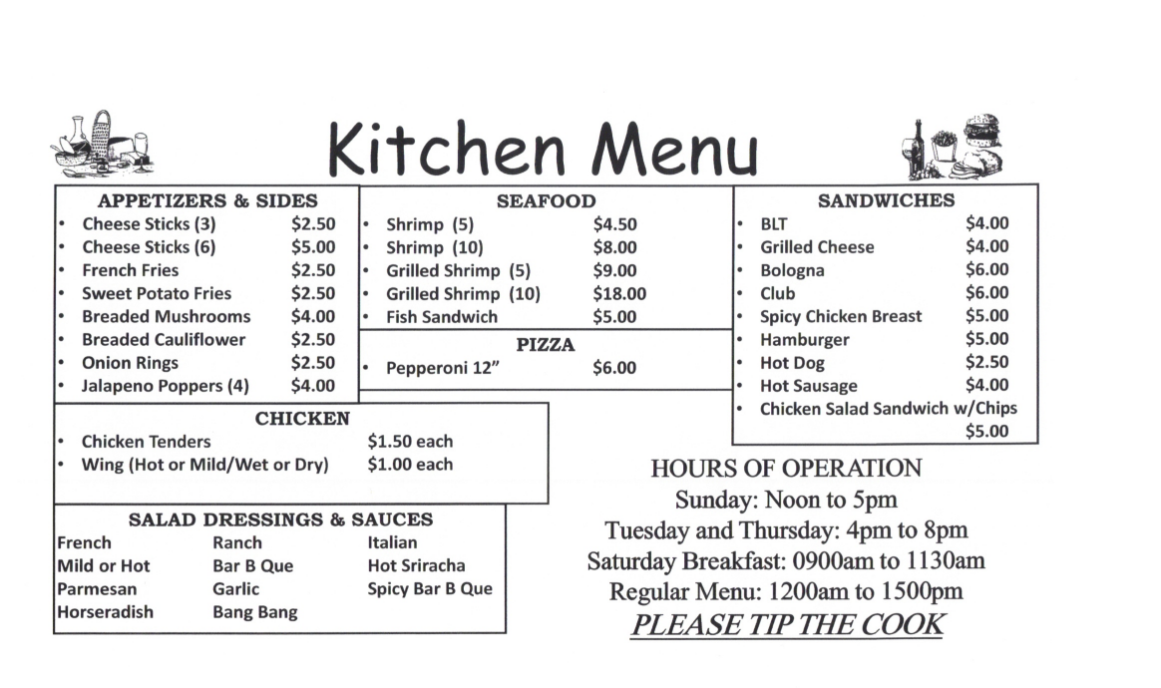

**BREAKFAST**

**Standard Breakfast: $10.00**

* (2) Eggs (Made to Order)
* (3) Pieces of Bacon or (2) Sausage Patties
* Home Fries
* (2) Slices of Toast (White, Wheat, Rye, or Texas Toast)

**Al A Carte:**

* Sausage Gravy & Biscuits (2) $6.00
* Breakfast Sandwich (Egg, Meat, & Cheese) $5.00
* Egg (1) $0.75
* Bacon (2) $1.00
* Sausage (1) $1.50
* Home Fries $2.00
* Coffee (Free refills) $0.75
* Mimosas $3.50
* Assorted Juices $1.00

(Orange, Cranberry, Cran-Mango, Pineapple, Diet Cranberry)