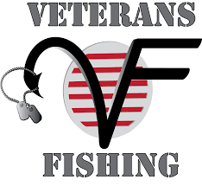
****SIGN UP NOW****

VFW 9857 WALLEYE FISHING TRIP
LAKE ERIE, PORT CLINTON, OHIO

See Sign-up sheet at VFW 9857
****The number of signed up members will determine the worthwhile of the fishing trip***

OPEN TO ALL 9857 MEMBERS (REGULAR MEMBERSHIP, AUXILLARY MEMBERSHIPS,
AND SOCIAL MEMBERSHIP).

DATE: One Day Only, Saturday, 25 April 2026.

****The deadline to sign up for the fishing trip is 3 April 2026, Limited to 35 members***

Additional information will be forthcoming: See Jay Glenn or call/text (614) 216-9155.

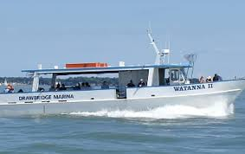

Recommend overnight lodging on the 24 April 2026, at the Best Western Port Clinton, OH. Each member must register their own lodging and has individual financial responsibility. See sign-up sheet located at the VFW Post 9857.

Fishing Boat: Shore Nuf Charters, at Drawbridge Mariana, 247 Lakeshore Dr, Port Clinton, OH 43452.

Hotel/Lodge: Best Western Port Clinton, 1734 E Perry St, Port Clinton, OH 43452. Phone: (419) 734-2274

Bring your own fishing rod(s) and tackle.

