*VFW Post 9857*

*Paul S. Lawrence*

*EUCHRE GAME NIGHT*

*COMING SOON*

*All Euchre Player Welcome!*

*2330 Stelzer Rd*

*Columbus, OH 43219*

*Sign-up Now, see sheet in the canteen area.*

*The number of individuals signed up will aid*

*in establishing a future date and time.*



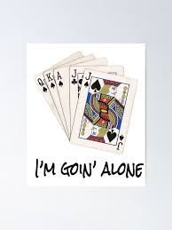

*Watch out for additional information.*

*Game rules will be provided and explained prior to game play.*

*POC: Linda Malone (614) 475-9188*