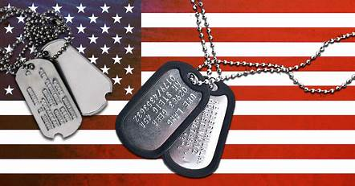
POPPY DRIVE
PAUL S. LAWERANCE MEMORIAL VFW POST #9857

PLEASE GIVE A DONATION TO OUR VETERANS TODAY

THANK YOU!
Military branch birthdays are observed throughout the year: The U.S. Army on June 14, 1775, the U.S. Navy on October 13, 1775, the U.S. Coast Guard on August 4, 1790, the U.S. Marine Corps on November 10, 1775, and the U.S. Air Force on September 18, 1947. The U.S. National Guard also has a birthday on December 13, 1636, and the U.S. Space Force on December 20, 2019.

